7.1.16 Editors - 3D View - Header - Mesh - Sculpt mode - Face Sets menu
Sculpt Mode - Face Sets Menu 1
Face Sets from Mask 1
Face Sets from Visible 1
Face Sets from Edit Mode Selection 1
Init Face Sets 1
Invert visible Face Sets 1
Show all Face Sets 2
Toggle Visibility 2
Hide active face sets 2
Randomize Colors 2

Sculpt Mode - Face Sets Menu

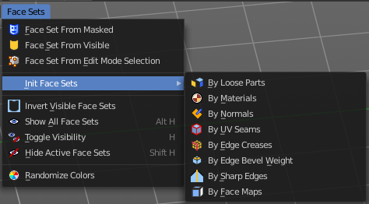
Face Sets is some kind of a mask that shows in different colors. The colors are random.
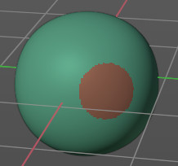

In the Face Sets menu you can create and manage Face Sets.

Face Sets from Mask
Creates a face set from the current mask.

Face Sets from Visible
Creates a face set from the visible geometry.

Face Sets from Edit Mode Selection
Creates a face set from the selection that you do in edit mode.

Init Face Sets
A menu with various methods to initialize the face sets.

Invert visible Face Sets
Inverts the visible face sets to be invisible.

Show all Face Sets
Show all face sets.

Toggle Visibility
Hotkey only tool! Hides and shows all geometry but the one from the face set under the mouse.

Hide active face sets
Hotkey only tool! Hides the face set under the mouse.

Randomize Colors
Generates a new set of random colors to render the face sets.

